Markup Languages

* Machine and human readable
* Relies on Tags
  + 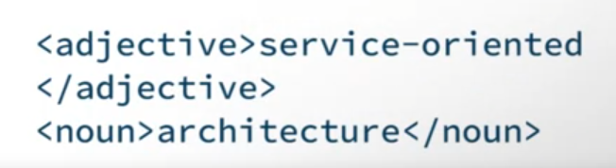
  + Often standard words
* No programming syntax

HyperText Markup Language (HTML)

* Structuring not styling

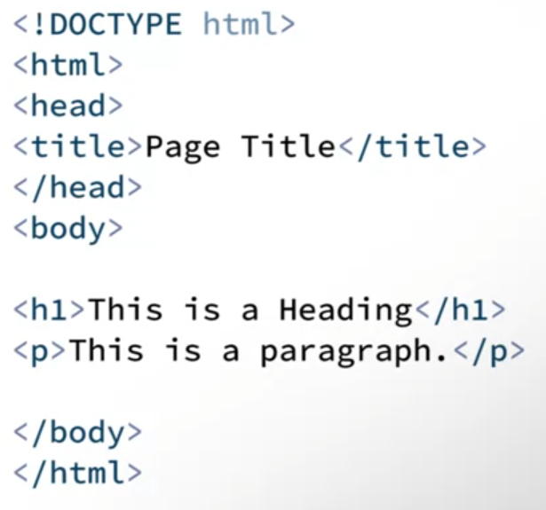

Cascading Style Sheet (CSS)

* For styling the HTML

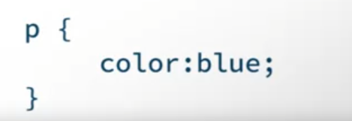

eXtensible Markup Language (XML)

* Store and transport language

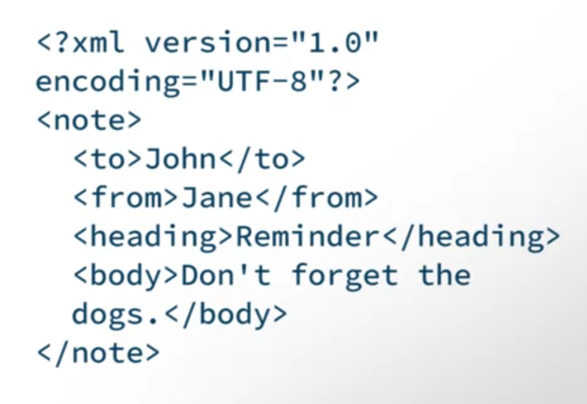

JavaScript Object Notation (JSON)

* Ability to easily convert JSON to JS Objects
* Transferring data from server and web, passing data from different services

